**Chapter 2: System Design**

**2.1 Physical Design**

**2.1.1 Block Diagram**

Data Entry Operator

Verifying

Login

Login list

Verified

Flight Details Customer & Reservation Detail Pnr No

Customer& Reservation Detail Maintenance

Flight Detail Maintenance

Cancellation

**Verified** Verifying Verified Verifying Verified

verifying

**Flight Detail**

Customer& Reservation List

Flight List

Verified Verifying

Flight Query

**Figure N0-6:- Block Diagram**

**2.1.2 Use case diagram**

Reservation Clerk

Customer

**Use case diagram for Airlines Reservation System**

**2.1.3 Data Flow Diagram**

**2.1.3.1 DFD 0 Level**

Data Entry Operator

Login Details

Booking detail

Ticket

customer

Cancellation

Detail of flight

**Data Flow Diagram of 0 level**

**2.1.3.1 DFD 1 Level**

Verifying

Data Entry Operator

Uid &Passwd Login detail

Verified

Customer & booking details Flight detail Flight id

Verifying Verified Verifying Verified

Customer& reservation Detail PNR no Flight detail

Verified

Verifying

**Data Flow Diagram of 1 level**

* 1. **2.1.4 Entity Relationship Diagram**

Reservation

Refer To

Flight

**ER Diagram of Airlines Reservation System**

**2.2 Database Design**

The information system of “Airlines Reservation System” performs its function with the help of the data store in certain repositories called Databases of the system. Detailed descriptions of the various databases included in the information systems are tabulated as follows:

**2.2.1 Login Database**

**C:\Users\SAS\Desktop\sct\newdatabase3.TIF**

**2.2.2 Flight Database**

**C:\Users\SAS\Desktop\sct\newdatabase2.TIF**

**2.2.3 Customer & Reservation Database**

**C:\Users\SAS\Desktop\sct\newdatabase1.TIF**

**2.3 Interface Design**

The interface design consists of the input and output source layouts. i.e. the input forms and screens and the report layouts that form as a source of outcome and income in the design and implementation of the information system under study

**2.3.1 Main Form**

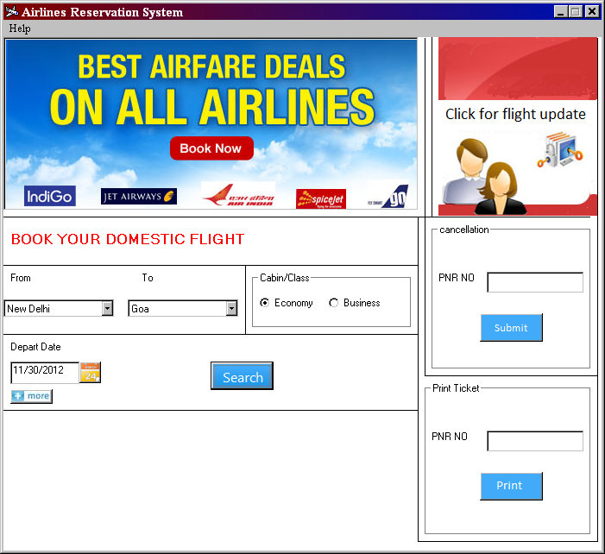

**C:\Users\SAS\Desktop\sct\untitled2.TIF**

Show the total no of flight

Show the result no

Show the Next flight

**C:\Users\SAS\Desktop\sct\untitled3.TIF**

Show the complete information of selected flight

**2.3.2 Customer information form**

**C:\Users\SAS\Desktop\sct\untitled4.TIF**

**2.3.3 Ticket Form**

**C:\Users\SAS\Desktop\sct\untitled5.TIF**

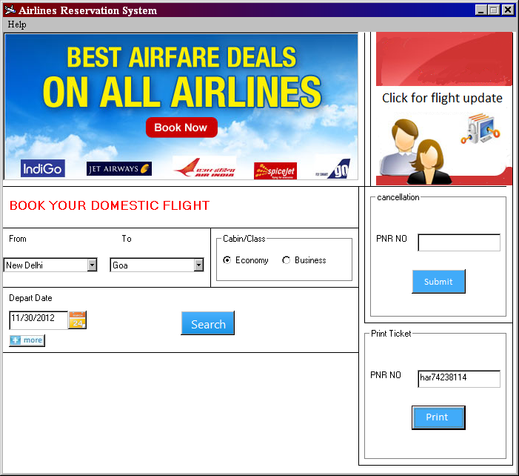

In case lose of ticket enter the PNR No and click on print

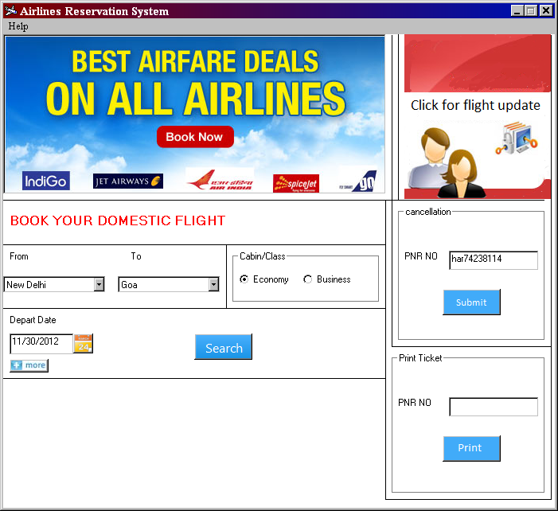

In case of ticket cancellation. enter the PNR No and click on submit

**2.3.4 Flight Entry Form**

C:\Users\SAS\Desktop\sct\untitled12.TIF